**Instruction: The pie charts below give statistics on the purposes of mobile phones and the information about the types of mobile phones people use. Describe the charts by selecting and reporting the striking points and make comparisons where relevant. Write at least 170- 250 words.**

**Description of the Graph(Handwritten):  
  
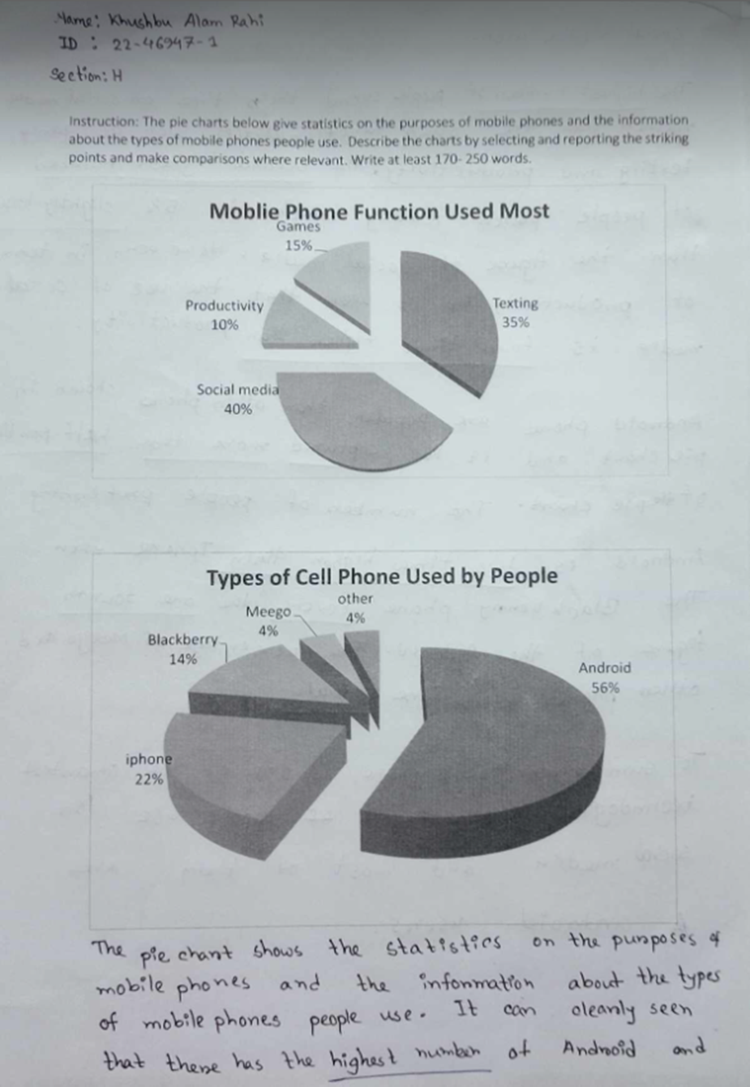**  
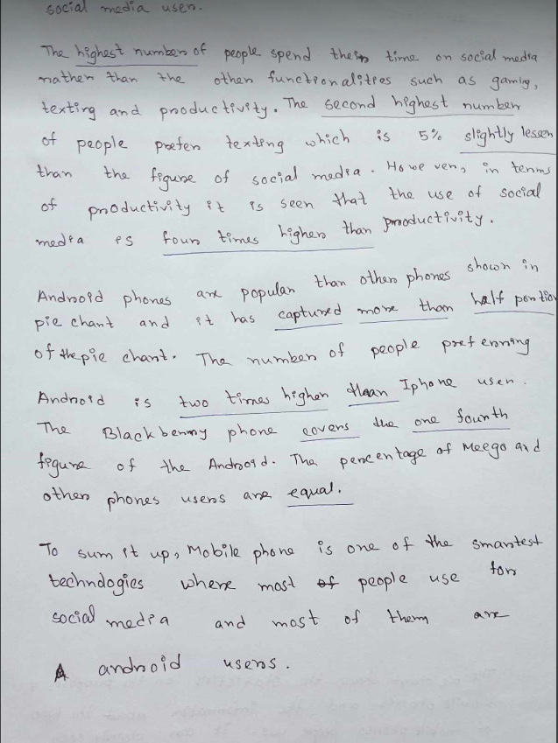  
 **Feedback from ChatGPT**:  
